1. Dataset plot
In this problem, we use the fetch_20newsgroups dataset from sklearn package to plot the number of training documents per class.
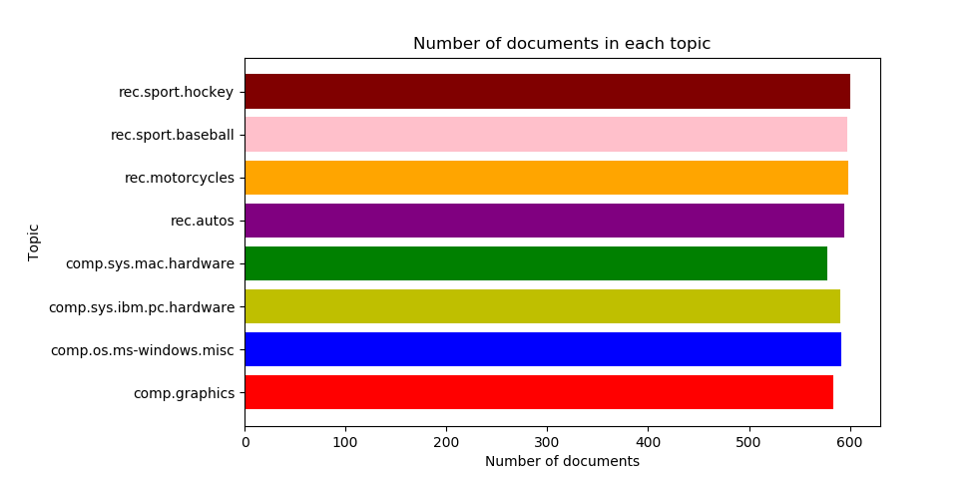
From the figure above, we could see that the data set is already balanced and in every class the number of documents is almost equivalent.

2. Create TF*IDF vector representation

A popular numerical statistic to capture the importance of a word is TFxIDF metric. This measure takes into account the words in the document. The discriminating words will most likely be those that are specialized terms describing different types of accessories and hence will occur in fewer documents.
In this problem, we need to convert the documents of 8 classes into numerical feature vectors. Firstly, we use ‘snowball’ to remove morphological affixes from words. After that, we remove all punctuation, all symbols and non-ascii characters. We used TfidfTransformer to calculate TFIDF, where tf(t, d) represents the frequency of term t in document d, and inverse document frequency is defined as: idf(t) = log [ n / df(t)] + 1 and df(t) is the document frequency; the document frequency is the number of documents that contain the term t.

Token shape: (4732, 21795) [min_df = 2, enable_stopword = True, enable_stem = True]

TFxIDF shape: (4732, 21795) [min_df = 2, enable_stopword = True, enable_stem = True]

[min_df = 2] Number of terms: 21795

Token shape: (4732, 8818) [min_df = 5, enable_stopword = True, enable_stem = True]

TFxIDF shape: (4732, 8818) [min_df = 5, enable_stopword = True, enable_stem = True]

[min_df = 5] Number of terms: 8818

3. Calculate the TF*ICF
In order to quantify how significant a word is to a class, we calculate TFxICF. It is the same as TFxIDF, except that a class sits in place of a document; that is for a term t and a class c. And we need to find the 10 most significant terms in each of the following classes with respect to TFICF measure.

alt.atheism [u'atheist', u'islam', u'god', u'write', u'atheism', u'peopl', u'subject', u'line', u'say', u'moral']

comp.graphics [u'imag', u'line', u'subject', u'jpeg', u'use', u'organ', u'file', u'graphic', u'x', u'ani']

comp.os.ms-windows.misc [u'maxaxaxaxaxaxaxaxaxaxaxaxaxaxax', u'm', u'q', u'vg', u'f', u'u', u't', u'd', u'fb', u'w']

comp.sys.ibm.pc.hardware [u'scsi', u'drive', u'ide', u'use', u'line', u'subject', u'organ', u'card', u'control', u'mb']

comp.sys.mac.hardware [u'line', u'mac', u'subject', u'organ', u'use', u'quadra', u'simm', u'appl', u'scsi', u'problem']

comp.windows.x [u'x', u'use', u'widget', u'window', u'line', u'subject', u'motif', u'file', u'r', u'program']

misc.forsale [u'line', u'subject', u'sale', u'organ', u'univers', u'new', u'use', u'offer', u'dos', u'nntppostinghost']

rec.autos [u'car', u'line', u'subject', u'organ', u'write', u'articl', u'ani', u'like', u'just', u'use']

rec.motorcycles [u'bike', u'line', u'organ', u'subject', u'dod', u'motorcycl', u'write', u'articl', u'ride', u'like']

rec.sport.baseball [u'line', u'subject', u'organ', u'year', u'game', u'team', u'write', u'basebal', u'pitch', u'pitcher']

rec.sport.hockey [u'hockey', u'team', u'nhl', u'game', u'playoff', u'play', u'line', u'subject', u'organ', u'pts']

sci.crypt [u'encrypt', u'key', u'clipper', u'use', u'chip', u'escrow', u'crypto', u'db', u'line', u'secur']

sci.electronics [u'line', u'use', u'subject', u'organ', u'wire', u'circuit', u'ani', u'ground', u'write', u'like']

sci.med [u'organ', u'subject', u'line', u'msg', u'use', u'gebcspittedu', u'write', u'articl', u'ani', u'diseas']

sci.space [u'space', u'orbit', u'line', u'organ', u'subject', u'launch', u'lunar', u'satellit', u'nasa', u'spacecraft']

soc.religion.christian [u'god', u'christian', u'jesus', u'church', u'subject', u'peopl', u'line', u'say', u'christ', u'believ']

talk.politics.guns [u'gun', u'firearm', u'peopl', u'weapon', u'line', u'organ', u'subject', u'write', u'use', u'handgun']

talk.politics.mideast [u'armenian', u'isra', u'turkish', u'israel', u'jew', u'peopl', u'arab', u'armenia', u'serdar', u'argic']

talk.politics.misc [u'stephanopoulo', u'peopl', u'write', u'q', u'articl', u'line', u'organ', u'think', u'dont', u'subject']

talk.religion.misc [u'christian', u'jesus', u'god', u'subject', u'line', u'organ', u'peopl', u'write', u'say', u'articl']

4. In this problem, we need to transform the data’s dimensional into a lower dimensional space. We use Latent Semantic Indexing (LSI) and NMF to lower the space into 50. As to LSI, we used the SVD decomposition to obtain left and right singular vectors and then get a lower space.

Token shape: (4732, 21795) [min_df = 2, enable_stopword = True, enable_stem = True]

TFxIDF shape: (4732, 21795) [min_df = 2, enable_stopword = True, enable_stem = True]

Shape of feature vec after LSI: (4732, 50)

Shape of feature vec after NMF: (4732, 50)

